**Internship/ Summer Training Assessment**

**on**

**MUSIC PLAYLIST RECOMMENDER [KCS-752]**

**Submitted as partial fulfillment for the award of**

**BACHELOR OF TECHNOLOGY**

**DEGREE**

**Session 2023-24**

**in**

**Computer Science and Engineering**

**By**

**Dheeraj Maurya**

**2000320100050**

**Mentor: Miss Sandhya Avasthi**

**ABES ENGINEERING COLLEGE, GHAZIABAD**

|  |  |  |
| --- | --- | --- |
| Description: C:\Users\es00952\Desktop\Logo.jpg | APJAK logo |  |

**AFFILIATED TO**

**DR. A.P.J. ABDUL KALAM TECHNICAL UNIVERSITY, U.P., LUCKNOW**

**(Formerly UPTU)**

**Internship/ Summer Training Assessment**

**on**

**AUDIO PLAYLIST RECOMMENDER [KCS-752]**

**Submitted as partial fulfillment for the award of**

**BACHELOR OF TECHNOLOGY**

**DEGREE**

**Session 2023-24**

**in**

**Computer Science and Engineering**

**By**

**Dheeraj Maurya**

**2000320100050**

**Mentor: Miss Sandhya Avasthi**

**ABES ENGINEERING COLLEGE, GHAZIABAD**

|  |  |  |
| --- | --- | --- |
| Description: C:\Users\es00952\Desktop\Logo.jpg | APJAK logo |  |

**AFFILIATED TO**

**DR. A.P.J. ABDUL KALAM TECHNICAL UNIVERSITY, U.P., LUCKNOW**

**(Formerly UPTU)**

**STUDENT’S DECLARATION**

I / We hereby declare that the work being presented in this report entitled “AUDIO PLAYLIST RECOMMENDER” is an authentic record of my own work carried out under the mentorship of Ms.Sandhya Avasthi.

The matter embodied in this report has not been submitted by me / us for the award of any other degree.

**Dated:** **Signature of student**

**Dheeraj Maurya**

**Department of CSE**

## This is to certify that the above statement made by the candidates is correct to the best of my knowledge. The submitted report has been run through a Plagiarism Check Software and the similarity Index is reported to be 11%.

|  |  |
| --- | --- |
| Signature of HoD-CSEProf. (Dr.) Divya Mishra(HoD-CSE)(Computer Science & Engineering Department) | Signature of Mentor/SupervisorMs.Sandhya Avasthi(Associate Professor)(Computer Science & Engineering Department) |

## 

## CERTIFICATE

This is to certify that Internship/ Training Report entitled “AUDIO PLAYLIST RECOMMENDER” which is submitted by DHEERAJ MAURYA in partial fulfillment of the requirement for the Engineering award of degree B. Tech. in Department of Computer Science and of Dr. A.P.J. Abdul Kalam Technical University, formerly Uttar Pradesh Technical University is a record of the candidate own work carried out by him/them under my supervision. The matter embodied in this thesis is original and has not been submitted for the award of any other degree.

The Plag report of this material contains 11% value and has been checked by me.

|  |  |
| --- | --- |
| Signature of HoD-CSEProf. (Dr.) Divya Mishra(HoD-CSE)(Computer Science & Engineering Department) | Signature of Supervisor/ MentorMs.Sandhya Avasthi(Assistant Professor)(Computer Science & Engineering Department) |

## 

**Dated:**

ACKNOWLEDGEMENT

*It gives us a great sense of pleasure to present the report of the B. Tech Internship/ Training undertaken during B. Tech. Final Year. We owe special debt of gratitude to our project guide / supervisor, Professor Ms.Sandhya Avasthi, Department of Computer Science & Engineering, ABESEC Ghaziabad for his constant support and guidance throughout the course of our work. His/ Her sincerity, thoroughness and perseverance have been a constant source of inspiration for us. It is only his cognizant efforts that our endeavors have seen light of the day.*

*We also take the opportunity to acknowledge the contribution of Professor (Dr.) Divya Mishra, Head, Department of Computer Science & Engineering, ABESEC Ghaziabad for her full support and assistance during the development of the project.*

*We also do not like to miss the opportunity to acknowledge the contribution of all faculty members of the department for their kind assistance and cooperation during the development of our project. Last but not the least, we acknowledge our friends for their contribution in the completion of the project.*

*Signature:*

*Name: Dheeraj Maurya*

*Roll No.: 2000320100050*

*Date :*

CRP Certificate

Audio Playlist Recommender

By

DHEERAJ MAURYA

ABSTRACT

***The Audio Playlist Recommender project aims to improve the music listening experience, by developing an intelligent system that suggests personalized playlists to users based on their preferences. In a world full of different music options, finding the right playlist takes most of the time. The project employs advanced algorithms to analyze user behavior and music characteristics.***

***The system uses collaborative filtering and content-based recommendation techniques to understand the user's interests. Collaborative filtering attempts to compare a user's preferences with those of others in order to suggest playlists for similar music lovers. Whereas, content-based recommendation relies on analyzing the audio characteristics of songs, such as tempo, genre, and mood, to match a user's unique musical palette.***

***To create an enabling user experience, the project includes a user-friendly content where individuals can provide feedback on suggested playlists, which helps support understanding of the system with their choices over time. This frequency learning process ensures that recommendations evolve and match the user's changing preferences.***

***Additionally, privacy and data security are prioritized during project development, ensuring user information is handled responsibly and clearly. By incorporating these ethical considerations, Audio Playlist Recommender not only enhances the enjoyment of music discovery but also prioritizes user trust and privacy.***

***In conclusion, this project offers a robust solution to the challenge of playlist selection, using collaborative filtering, content-based recommendation, and continuous user feedback to provide a personalized and enjoyable music journey for each user.***

**TABLE OF CONTENTS** Page

DECLARATION ................................................................................................... 3

CERTIFICATE……............................................................................................... 4

ACKNOWLEDGEMENT....................................................................................... 5

SUMMER INTERNSHIP /TRAINING CERTIIFICATE.......................................... 6

ABSTRACT…………………………………………………………………………….. 7

TABLE OF CONTENT.......................................................................................... 8

LIST OF FIGURES............................................................................................... 9

LIST OF ABBREVIATIONS ................................................................................. 10

CHAPTER 1 INTRODUCTION

1.1. PROBLEM INTRODUCTION.................................................................. 11

1.2. RELATED PREVIOUS WORK…............................................................ 12

1.3. ORGANISATION OF THE REPORT……………………………………… 12

CHAPTER 2 LITERATURE SURVEY……........................................................ 13

CHAPTER 3 METHODOLOGY……………………………................................. 14-15

CHAPTER 4 IMPLEMENTATION AND RESULTS ........................................... 16-18

CHAPTER 5 CONCLUSION ............................................................................. 19

REFERENCES.................................................................................................. 20

**LIST OF FIGURES**

* **Figure 1 Page 17**
* **Figure 2 Page 18**
* **Figure 3 Page 18**
* **Figure 4 Page 19**
* **Figure 5** **Page 19**

**LIST OF ABBREVIATIONS**

KNN K-Nearest Neighbors Algorithm

SVD Singular Value Decomposition

RAM Random Access Memory

Mac OS Macintosh Operating System

**CHAPTER 1**

**INTRODUCTION**

* 1. **Problem Introduction**

In today's digital age, we have an abundance of music sources to listen to, but creating a playlist that truly matches our tastes can be a challenging task. Introducing the 'Audio Playlist Recommender' project, designed to simplify and enhance your music exploration experience. The project attempts to understand your music preferences using smart algorithms and machine learning, such as by analyzing your listening history and current context. Our goal is to make creating personalized playlists effortless, ensuring that the music you love is always at your fingertips. Leveraging technology, we aim to transform the way you discover and enjoy your favorite songs, ultimately providing an exclusive and delightful audio journey into the vast realm of digital music streaming.

**1.1.1.Motivation**

The Motivation behind this project is to enhance the user music experience, using machine learning algorithms to analyze user preferences and suggest personalized playlists. The project aims to save time for users, creating automatic playlists based on their listening history, preferences, and perhaps contextual factors such as past activity. It aims to provide an exclusive and enjoyable music exploration process, ultimately increasing user satisfaction with the audio streaming platform.

**1.1.2.Project Objective**

The primary objective of this research and project is to improve the user music experience by prioritizing the use of advanced algorithms to analyze preferences and behavior. Using machine learning it suggests personalized playlists based on personal interests, creating an expert audio journey. The project aims to provide an intuitive and enjoyable music discovery process, promoting user retention and satisfaction in the field of audio content consumption.

**1.1.3.Scope Of The Project**

The scope of the project includes creating an audio playlist recommendation system that assesses user preferences and behavior to provide personalized playlist suggestions. This includes algorithm development for content recommendations, incorporating user feedback features, and building an intuitive interface. Additionally, the project may address data collection, storage, privacy and include features such as playlist creation, collaborative filtering, and adaptive learning for improved accuracy and user satisfaction. Extensive testing, performance optimization and scalability considerations are essential components of the project scope.

* 1. **Related Previous Work**
* The Million Song Dataset by McFee et al. (2012) offers rich audio features and metadata, forming a crucial foundation for audio playlist recommenders. Explore collaborative filtering, genre information, and research insights.
* T. Bertin and colleagues created "The Million Song Dataset", presented at the 12th International Society for Music Information Retrieval. This dataset is known for its rich audio features and metadata, which has become a core structure in the field of music information retrieval and recommendation systems. By providing large collections of songs that include detailed features, Bertin and collaborators' work has improved understanding of musical patterns, user preferences, and collaborative filtering techniques.
* Yehuda Koren is known for his work in collaborative filtering techniques. In their seminal paper "Factorization Meets the Neighborhood: A Multifaceted Collaborative Filtering Model", they introduced a model combining matrix factorization with neighborhood-based methods. The objective was to improve the accuracy of recommender systems by taking advantage of feedback received from direct and sometimes arbitrary counterparts. The model aimed to overcome the legacy and scalability challenges that often arise in collective filtering approaches.
  1. **Organization of the Report**

The report is organized to systematically present the developments and findings of the Audio Playlist Recommender. The sections that follow highlight the methodology, implementation, results and conclusions, providing a comprehensive overview of the project's progress and outcomes.

**CHAPTER 2**

**LITERATURE SURVEY**

Sarwar et al. (2001) and Breese et al. (1998) is the basic framework of playlist recommenders. Collaborative filtering leverages user-item interactions to identify patterns based on similar users' preferences and make playlist recommendations based on users with similar interests. The K-Nearest Neighbors (KNN) algorithm described by Desrosiers and Karipis (2011) further improves collaborative filtering, as it takes into account the preferences of users with similar interests.

Singular value decomposition has contributed significantly to recommendation systems. Koren et al. (2009) showed the application of singular value decomposition to collaborative filtering, improving its ability to factorize the user-item interaction matrix and demonstrating improved accuracy of recommendation. Improving the ability of SVD to capture the influence factors embedded in collaborative models increases the efficiency of the system.

Content-based methods, which Melville et al. (2002) and Pauwels et al. (2013) explored, including examining audio features such as genre, tempo, and artist information. Combining content-based features with collaborative filtering increases recommendation accuracy. The KNN-SVD model incorporates content attributes into a collaborative framework, allowing a more multifaceted understanding of user preferences.

Evaluation metrics, including precision, recall, and mean average precision (MAP), as described by Janach et al. (2015) described, playlists are important to evaluate the performance efficiency of recommenders. These metrics help further refine the KNN-SVD model, ensuring that it is accurate and meaningful enough to meet user expectations.

**CHAPTER 3**

# Methodology

**Overview of the proposed System**

# Popularity Based: -

Popularity-based approaches to audio playlist recommendation are helpful in suggesting new music using group intelligence. These systems analyze a user's listening habits across platforms, identifying frequently played songs, artists, or genres. Based on this popularity data, these systems recommend items that other users with similar interests are likely to enjoy listening to. This approach is simple and effective, especially for new users or those looking primarily for popular music.

# KNN MODEL: -

# KNN (K-Nearest Neighbors) is used in audio playlist recommender systems to make music suggestions based on the user's current listening preferences. It works by determining the most similarity of songs based on the audio characteristics provided by the user and ratings given by other users with similar interests. The system then calculates the "distance" between songs, such as Euclidean distance or cosine similarity, taking into account audio characteristics and user scores. The system then recommends the "K" most closely similar songs, creating a playlist that matches with the user's current preferences and listening habits.

# SVD MODEL: -

# In Audio Playlist Recommender, SVD models act as musical intelligence, traversing vast forests of listening data to discover hidden relationships between users and songs. Imagine a giant carpet woven from the listening habits of thousands of people, SVD meticulously untangles its strings, and gradually identifies what kind of music people enjoy. By understanding these “music signatures,” SVD creates personalized playlists that resonate with your heartbeat, uncovering unheard songs you may never hear

# Evaluation Metrices: -

# The evaluation metrics in Audio Playlist Recommender work like experienced music critics, carefully assessing the quality of recommendations to ensure they align with users' tastes. Some key metrics include:

# Precision: These measures how closely the recommendations match the user's preferences.

# Recall: These measures how many relevant songs have been found.

# MAP (Average Precision): These rewards playlists that put the most relevant songs at the top.

# NDCG (Discounted Cumulative Gain): This gives priority to highly relevant songs coming first in the playlist.

# F1-Score: This strikes a balance between accuracy and recovery.

# By carefully selecting and interpreting these metrics, creators can create recommender systems that deliver playlists that truly resonate, tailored to the unique tastes of each individual user.

**CHAPTER 4**

# IMPLEMENTATION AND RESULTS

* 1. **Software and Hardware Requirements**
* **Hardware Requirements:** 
  + RAM: 4 GB
  + Storage: 500 GB
  + CPU: 2 GHz or faster
  + Architecture: 32-bit or 64-bit
* **Software Requirements:** 
  + Python 3.5 or higher in Jupyter Notebook is used for data pre-processing, model training
  + HTML, CSS, JAVASCRIPT for frontend.
  + Operating System: windows 7 and above or Linux based OS or MAC OS

1. **Implementation Details**
   1. **Snapshots of Code**

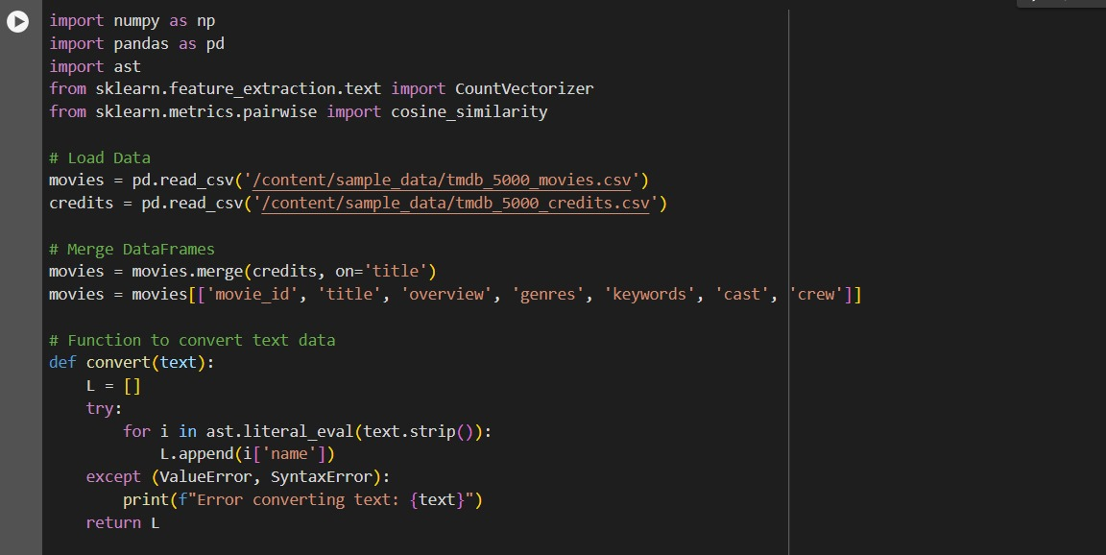

**Figure 1**

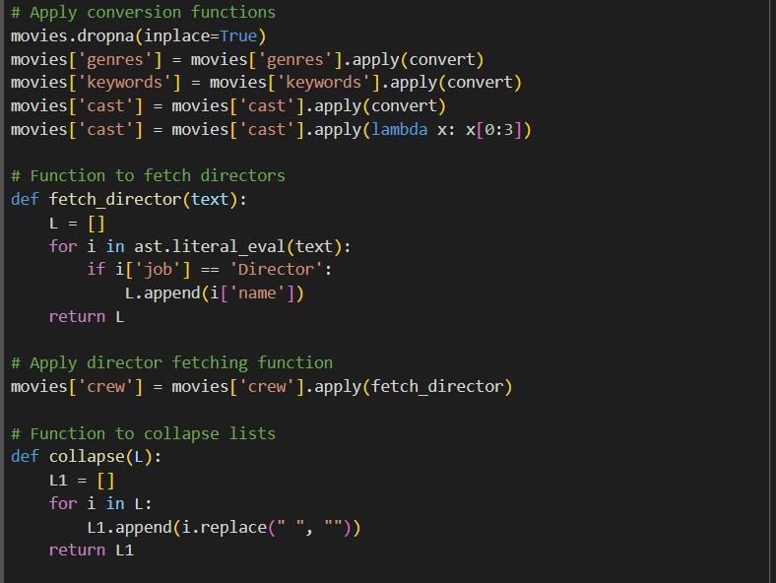

**Figure 2**

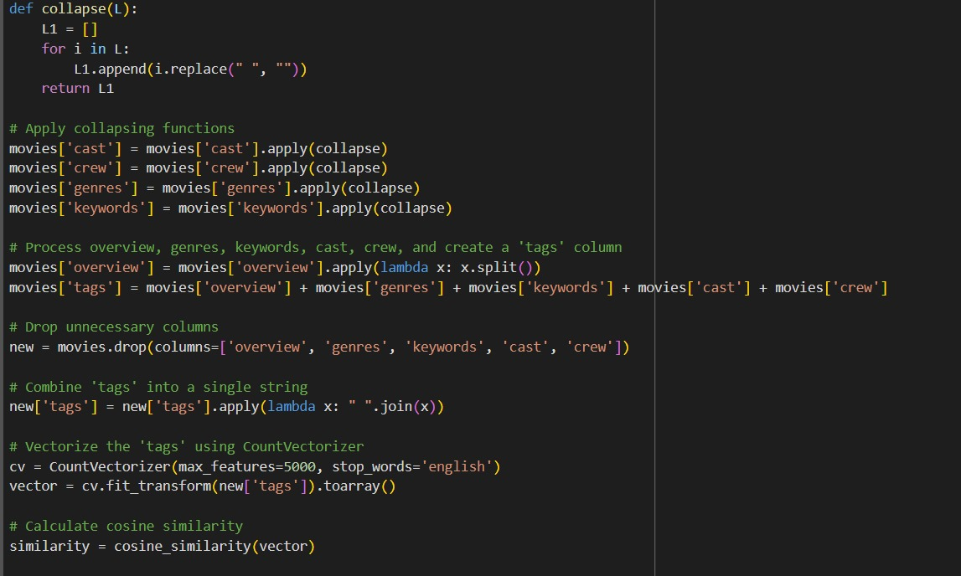

**Figure 3**

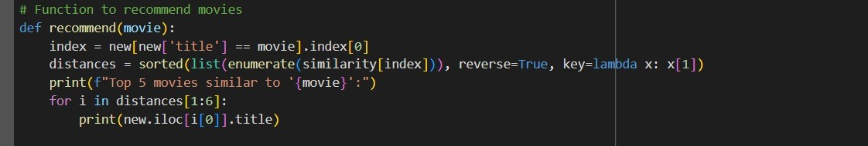

**Figure 4**

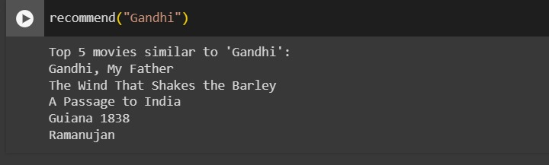

**Figure 5**

**CHAPTER 5**

# CONCLUSION

**Audio Playlist Recommender project has succeeded in fulfilling its purpose of providing personalized music suggestions to users, making the listening experience much better. The effectiveness of the project lies in its complex algorithms, which analyze user preferences and behavior to create playlists dedicated to personal interests. Using machine learning models, the system is able to continuously improve its suggestions, providing a dynamic and engaging platform based on user preferences.The impact of Audio Playlist Recommender is not just about creating playlists, but it also creates a stronger connection between users and their music libraries. It introduces new songs and supports the repetition of favorite songs, creating a new and fun music experience. The project's innovative approach is in the changing context of technology-infused music enhancements, showing potential in personalization using artificial intelligence.Looking to the future, Audio Playlist Recommender embodies the confluence of advanced algorithms and user-centric design. It not only meets, but sets a standard for smooth and graceful integration of technology into music research and enjoyment.**

**References**

[1] McFee, B., BertinMahieux,T., Ellis, D. P., Lanckriet, G. R. (2012, April). The million song dataset challenge. In Proceedings of the 21st international

conference companion on World Wide Web (pp.

909916)ACM.

[2] Aiolli, F. (2012). A preliminary study on a recommender system for the million songs dataset challenge. PREFERENCE LEARNING: PROBLEMS AND APPLICATIONS IN AI.

[3]. Koren, Yehuda. ”Recommender system utilizing collaborative filtering combining explicit and implicit feedback with both neighborhood and latent factor models.”

[4]. Cremonesi, Paolo, Yehuda Koren, and Roberto Turrin. ”Performance of recommender algorithms on topn recommendation tasks.”Proceedings of the fourth ACM conference on Recommender systems.

ACM,2010.

[5] T. Bertin et al., The Million Song Dataset, Proc. of the 12th International Society for Music Information Retrieval Conference, 2011.

[6] Sparse Matrices <http://docs.scipy.org/doc/scipy/reference/sparse.html>

[7]

Mahiux.Ellis(2-11)http://labrosa.ee.columbia.edu/millionsong/tasteprofile